FOOD DELIVERY BOT USING D* LITE ALGORTIHM

Project submitted to the SASTRA Deemed to be University in partial fulfillment of the requirements for the award of the degree of

B. Tech. Robotics and Artificial Intelligence

Submitted by

HARI HARAN R
(Reg. No.:128179012)
HARJITH R S
(Reg. No.:128179017)

May 2026



SCHOOL OF ELECTRICAL & ELECTRONICS ENGINEERING

THANJAVUR, TAMIL NADU, INDIA – 613 401


SCHOOL OF ELECTRICAL & ELECTRONICS ENGINEERING
THANJAVUR – 613 401

Bonafide Certificate

This is to certify that the project-based assessment report titled “Food delivery bot” submitted in partial fulfilment of the requirements for the award of the degree of B. Tech. Robotics & Artificial Intelligence Engineering to the SASTRA Deemed to be University, is a bona-fide record of the work done by Mr.Harjith.R.S (Reg. No.128179017) and Mr.Hari Haran. R during the IV semester of the academic year 2025-26, in the School of Electrical & Electronics Engineering, under my supervision for the course titled Introduction to Artificial Intelligence (EIE115R01).

Course Co-ordinator
Name with Affiliation | : Dr. K. Ghousiya Begum, Assistant professor III
Date | :
Project Viva-voce held on

ii

TABLE OF CONTENTS
Title | Page No.
Bonafide Certificate | ii
Declaration | iv
Acknowledgement | v
1.Abstract | 1
2. Introduction | 2
3. Methodology | 3
3a. Working of the system | 3
3b. Path Planning using D* Lite Algorithm | 3
3c. Obstacles Detection | 3
3d. QR Code Detection using OpenCV | 3
3e. Hardware | 3
4. Result | 5
5. Conclusion | 6
6. Future Scope | 6
7.Reference | 8

iii


SCHOOL OF ELECTRICAL & ELECTRONICS ENGINEERING THANJAVUR – 613 401

Declaration

I declare that the report titled “Food Delivery Bot” submitted by me is an original work done by me under the supervision of Dr. K. Ghousiya Begum, Assistant professor III, School of Electrical and Electronics Engineering, SASTRA Deemed to be University during the fourth semester of the academic year 2025-26, in the School of Electrical and Electronics Engineering. The work is original and wherever I have used materials from other sources, I have given due credit and cited them in the text of the thesis.
Signature of the candidate :

Name of the candidate:
HARJITH.R. S (Reg. No. 128179017, B.Tech AIR)
HARIHARAN R (Reg. No. 128179012, B.Tech AIR)

Date :

Acknowledgements

I would like to thank our Honorable Chancellor Prof. R. Sethuraman for providing me with an opportunity and the necessary infrastructure for carrying out this project as a part of my curriculum.

I would like to thank our Honorable Vice-Chancellor Dr. S.Vaidhyasubramaniam and Dr. S. Swaminathan, Dean, Planning & Development, for the encouragement and strategic support at every step of our college life.

I extend my sincere thanks to Dr. R. Chandramouli, Registrar, SASTRA Deemed to be University for providing the opportunity to pursue this project.

I extend my heartfelt thanks to Dr. K .Thenmozhi, Dean, School of Electrical and Electronics Engineering ,Dr. Sridhar K, Dean, Research, Dr. V. Muthubalan, Associate Dean, Research, Dr. A. Krishnamoorthy, Associate Dean, Academics, Dr. Manigandan N.S., Associate Dean, Infrastructure, Lt. Dr. Vijayarekha K, Associate Dean, Students Welfare.

Dr. K. Ghousiya begum, my course coordinator and Assistant Professor-III at the School of Electrical and Electronics Engineering, was the driving force behind my project idea. Her expertise and advice were incredibly helpful throughout.

v

Abstract

Our project presents a design and execution of an autonomous Food Delivery Robot that utilises advanced path planning and security verification mechanisms. The robot uses the D* Lite algorithm for efficient and dynamic path planning in environments with obstacles. Real-time obstacle detection is achieved using an ultrasonic sensor to enable safe navigation. The robot uses QR code-based verification using OpenCV pipelines to ensure secure delivery. Once the robot reaches the destination (goal position), the robot verifies the customer by scanning a QR code through its camera module. If the QR code matches the expected pattern, the robot automatically opens its lid. The robot also includes an interpreter sensor to measure the wheel rotation for accurate movement tracking and a Bluetooth communication module to transfer data between the system and robot.

A simulation system continuously communicates with the robot, providing commands and receiving real-time data to update the algorithm and monitor the robot motion. The proposed system demonstrates an efficient, reliable and human contactless solution for automated food delivery in a known and controlled environment.

CHAPTER 1

INTRODUCTION
With the increasing demands for automation in service industries, robotic systems are being widely used to improve efficiency and reduce human intervention. One such application is automated food delivery in environments such as restaurants, hospitals and campuses. Usual delivery methods rely heavily on human labour, which reduces efficiency, increases delays, increases operational costs, and puts human contact with food products at risk of spreading contagious diseases.
One of the main challenges in mobile robotics is path planning in dynamic environments. To resolve this challenge, our system uses the D* Lite algorithm, which enables real-time replanning of the path when obstacles are detected. Another important sphere in food delivery is safe delivery. This project integrates QR code-based verification using OpenCV, ensuring that only the intended customer can access the delivered item. The robot combines multiple subsystems, including navigation, obstacle detection, customer verification and communication, to deliver a complete autonomous solution.

Problem Statement
Delivering product without human intervention efficiently has become a big challenge in places where human contact with the product could lead to contamination and using human resources for such minimal tasks is not efficient in a known environment. To resolve all these needs an automated system can ensure reliable, efficient and error-free product delivery.

Objective of the Project
The main objective of the project is to build an automated robot system for food delivery in a known environment. The robot posses the ability to reach the desired destination efficiently by replanning its path when interfered by any dynamic obstacle using D* Lite algorithm. The robot must also authenticate its user using OpenCV pipelines.

CHAPTER 2

METHODOLOGY

This system consists of both hardware and software components working together to achieve autonomous delivery.
Working of the system
The robot operates in the following sequence:
- Receives destination input via simulation system.
- Plans optimal path using D* Lite algorithm.
- Re-plans route when obstacle are included.
- Navigates while avoiding obstacles.
- Reaches destination
- Scans QR code for authentication.
- Opens lid upon successful verification.
Path Planning using D* Lite Algorithm
The D* Lite algorithm is used for efficient pathfinding in dynamic environments. It allows the robot to recalculate its path with respect to the goal when obstacles are detected, making it highly suitable for real-time navigation.
Obstacles Detection
Ultrasonic (US) sensors are used to detect obstacles in the robot’s path. When an obstacle is detected, the robot updates its path using the D* Lite algorithm. We have used HC-SR04 ultrasonic sensor.
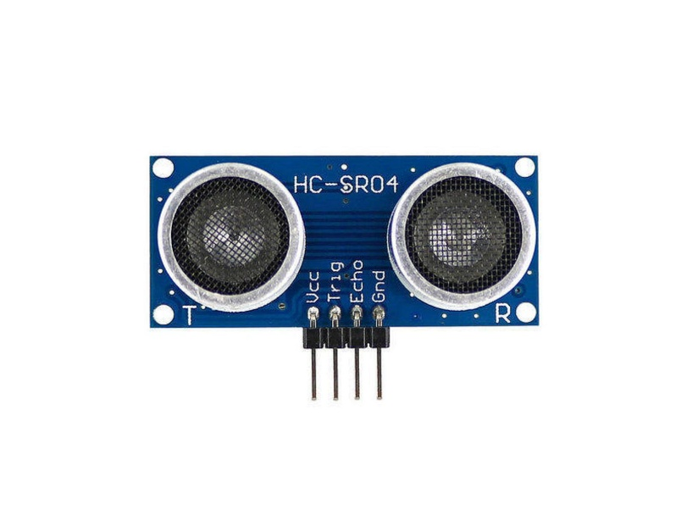

QR Code Detection using OpenCV
The robot uses a camera module integrated with OpenCV pipelines to detect and decode QR codes. It does the following:-
- Captures image
- Processes using OpenCV
- Extracts QR data
- Matches with stored data
If the QR code is valid, the delivery lid opens automatically.

Hardware

Motor Driver
The directions of the robot are being controlled by differential drive method. To control the motors, we have used L298N Dual H-bridge Motor Driver module.
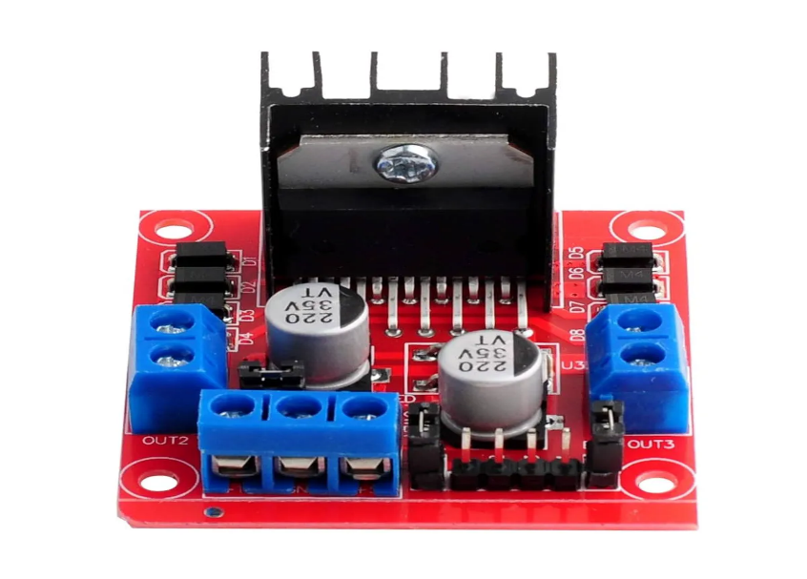
Battery
We used 4 Lithium-ion rechargeable battery of 3.7V each to aggregate a net voltage of 12V.
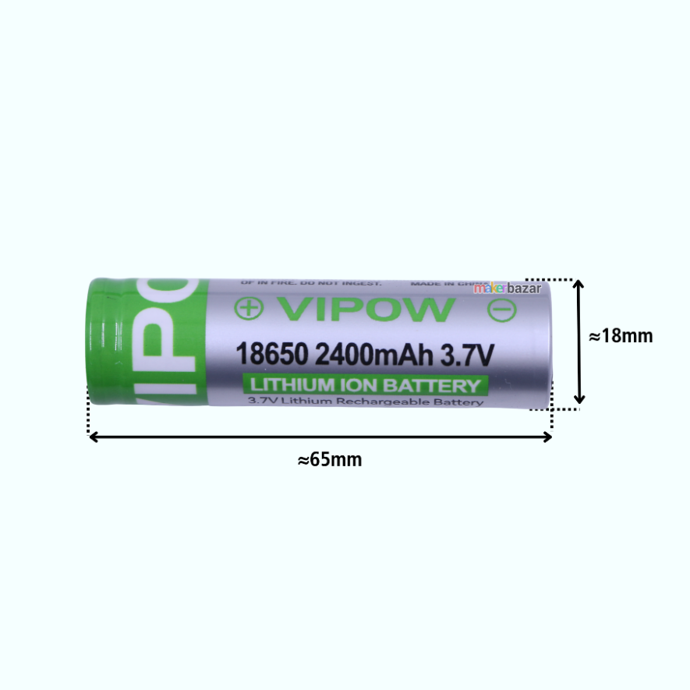

DC Buck Driver
We used a LM2596 DC-DC Buck driver to step down the higher input voltage to a save limit of 12V.
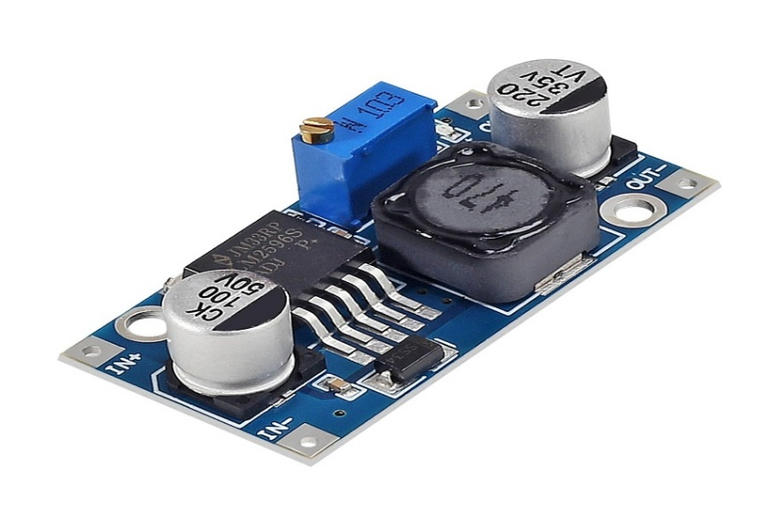
Wheel Rotation Measurement
A speed sensor LM393 is used to measure wheel rotation speed, which helps in :-
- Distance calculation
- Speed monitoring
- Accurate navigation
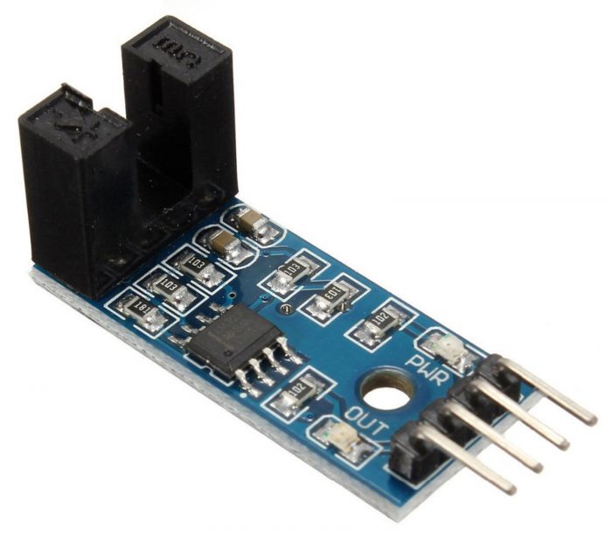

Display
An OLED display is used to display the message transmitted through the QR code.
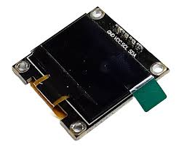

Micro-Controller
We used Arduino UNO microcontroller to send commands to various parts of the robot.
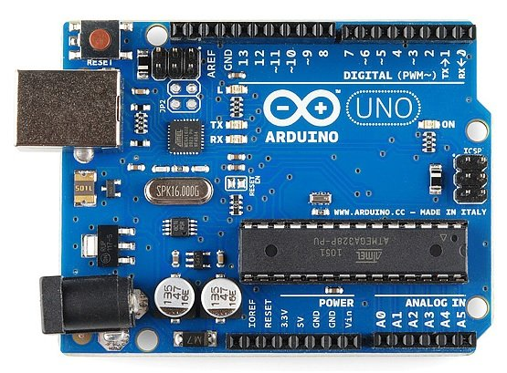

Communication System
Bluetooth module enables:
- Wireless code upload
- Command transmission
- Real-time monitoring
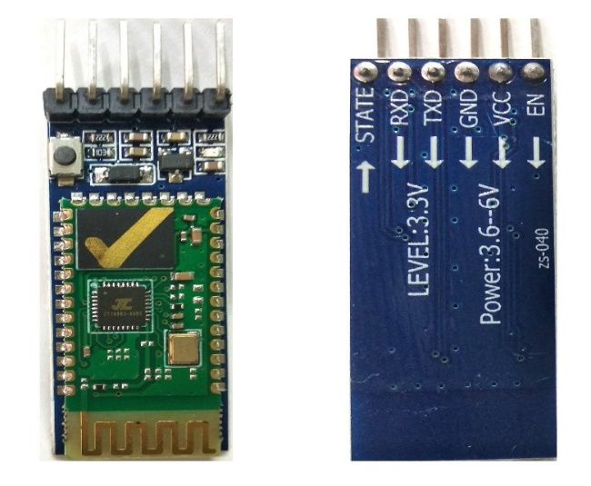
Bluetooth Module
Simulation Integration
A simulation system is used to: -
- Send commands to the robot
- Receive real-time data
- Monitor robot behaviour
Flowchart of D* Lite Algorithm
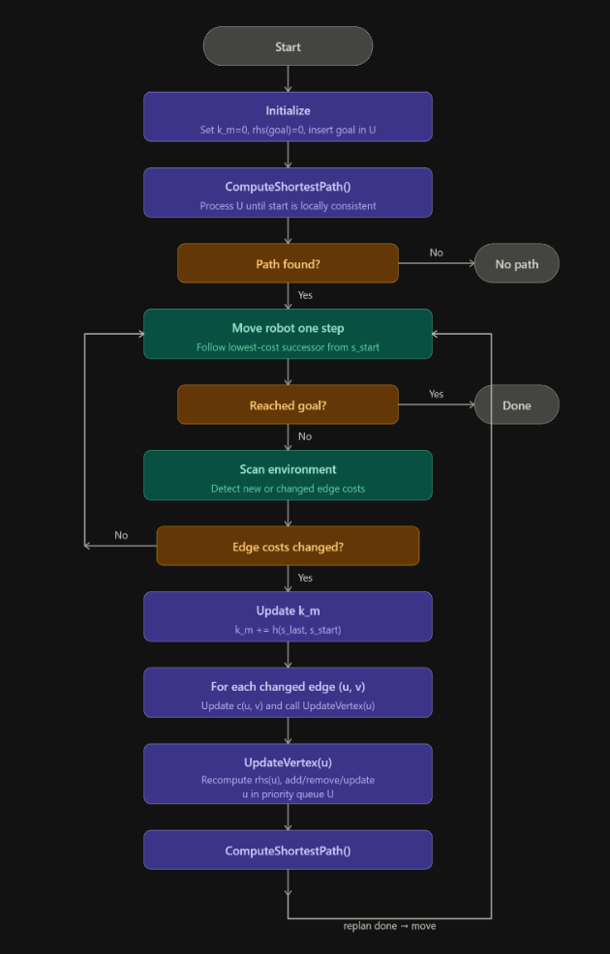

CHAPTER 3

RESULTS AND DISCUSSION

[The developed system was tested in a controlled environment with pre-defined delivery points.]

Observations:
- The robot successfully navigated using D* Lite algorithm.
- The robot altered its path effectively as per the sub-goals.
- Obstacles were detected and avoided efficiently.
- QR code authentication worked successfully.
- Communication between the simulation and the robot was stable.

Performance Metrics:
- High navigation accuracy.
- Reliable QR detection
- Efficient obstacle avoidance
- Smooth real-time communication

The system demonstrated adaptability in dynamic conditions successfully.
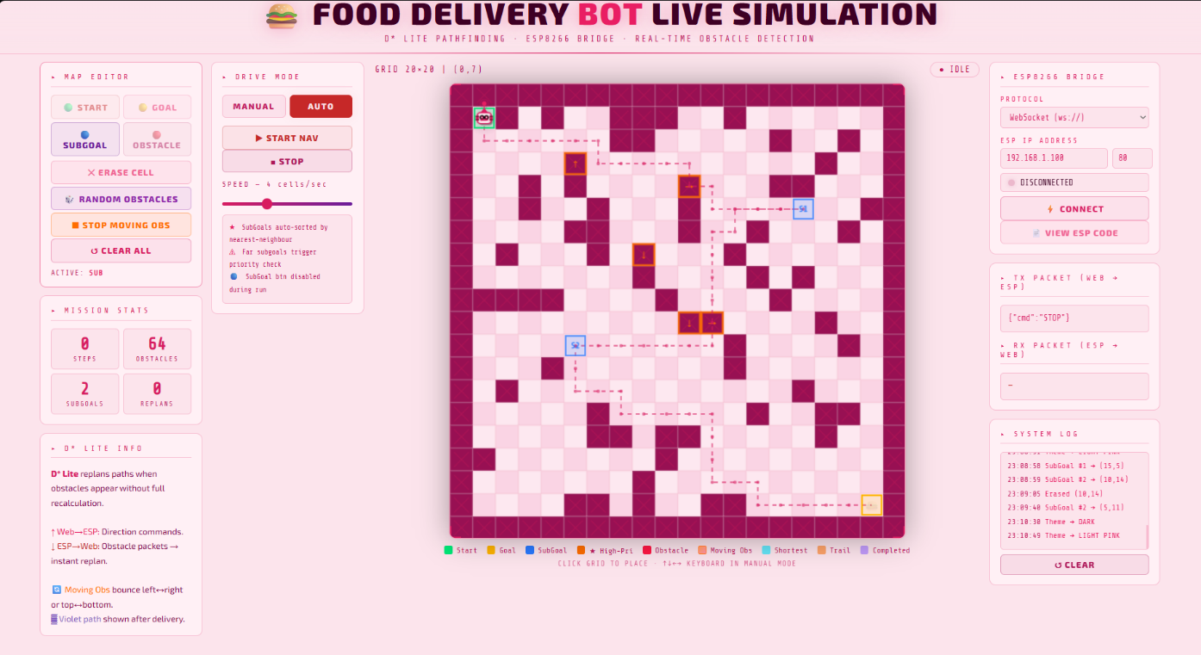

BOT IMAGE
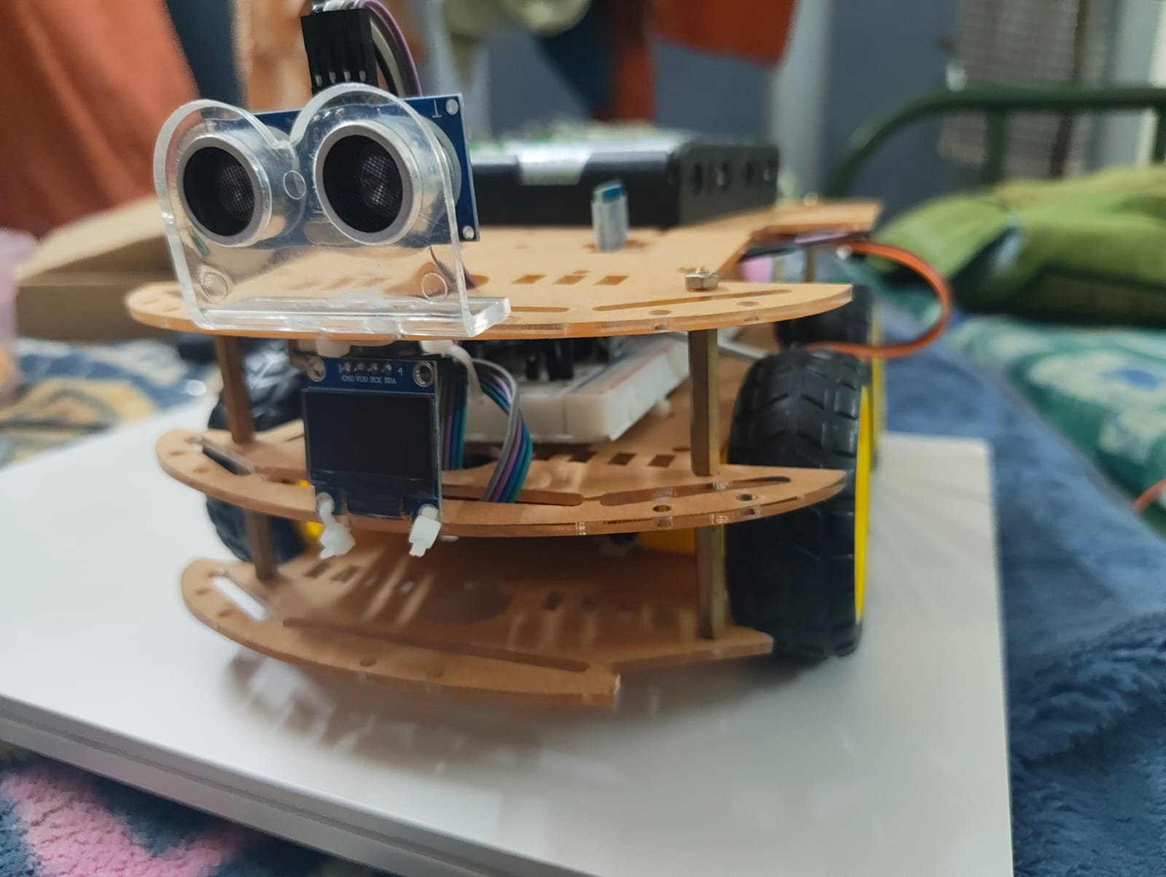

CHAPTER 4

CONCLUSIONS AND FUTURE SCOPE

The autonomous Food Delivery Robot developed in this project successfully demonstrates a efficient solution for contactless delivery in controlled environments. By integrating the D* Lite algorithm for dynamic path planning, the system effectively navigates through environments with real-time obstacle handling. The use of ultrasonic sensors ensures safe navigation, while the QR code-based authentication mechanism implemented using OpenCV enhances delivery security by restricting access to authorized persons.
The combination of hardware components such as wheel rotation sensors for precise motion tracking and Bluetooth module for seamless communication contributes to the overall stability to the system. Additionally, the simulation system plays a crucial role in monitoring and controlling the robot, enabling real-time data exchange and performance evaluation.
The results confirm that the robot can:
- Navigate in the dynamic environments
- Adapt to obstacles avoidance efficiently
- Perform secure and contactless delivery
- Maintain stable communication with the control system
Overall, the project achieves its objective of developing a smart, autonomous delivery system that reduces human effort, improves efficiency, and supports hygienic service operations.

- The robot can be made smarter by adding AI and Machine Learning, so it can learn from its environment and make better decisions while navigating.
- It can be upgraded to work in completely new places by using SLAM, allowing it to create maps and move without predefined paths.
- Instead of basic ultrasonic sensors, more advanced technologies like LiDAR and depth cameras can be used to improve obstacle detection and accuracy.
- The security system can be strengthened by adding facial recognition along with QR verification using OpenCV, making delivery safer.
- By integrating with cloud systems, all robot data can be stored and analysed to improve performance over time.
- A user-friendly mobile app can be developed so customers can track the robot and interact with it easily.
- The robot can be designed to automatically return to a charging station, improving its usability without human intervention.
- Future versions can work outdoors by adding GPS and making the robot resistant to weather conditions.
- The carrying capacity of the robot can be increased to handle larger or multiple deliveries.
- Multiple robots can be used together as a team to handle more deliveries efficiently.
- Features like voice interaction can be added to make communication between humans and the robot more natural.
- Communication systems can be improved by moving beyond Bluetooth to faster and more reliable technologies like Wi-Fi or 5G.
- Better battery management can be implemented to increase the robot’s working time.
- Finally, the system can be integrated into smart campuses and smart cities, making it useful on a much larger scale.

REFERENCES

- Yu, X., Wu, X., & Han, S. (2019). A Robust QR Code-Based Localization Method for Indoor Robots. IEEE Access, 7, 163251-163261.

- Koenig, S., & Likhachev, M. (2002). D* Lite. Proceedings of the National Conference on Artificial Intelligence (AAAI), 476-483

- Likhachev, M., & Koenig, S. (2005). Incremental Planning with Search. Advances in Neural Information Processing Systems (NIPS), 18, 1145-1152.

- Thrun, S., Burgard, W., & Fox, D. (2005). Probabilistic Robotics. MIT Press.

- Ye, L., & Zhou, Y. (2022). Real-Time Path Planning for Robot Using Improved D* Lite in Complex Dynamic Environments. Frontiers in Neurorobotics, 16, 915432.

